Лекция 12
ПСКП
ПОИТ-3

Node.js: MongoDB

- MongoDB: https://metanit.com/nosql/mongodb/
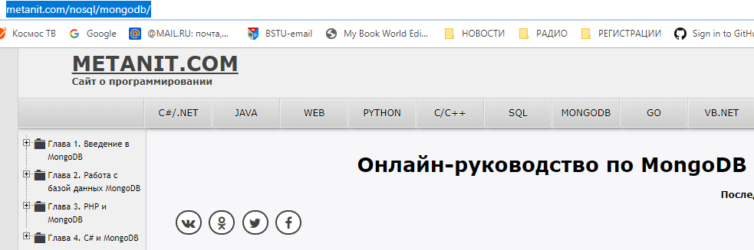
- MongoDB: https://metanit.com/web/nodejs/6.1.php
- MongoDB: http://mongodb.github.io/node-mongodb-native/3.1/api/index.html
- MongoDB: https://www.npmjs.com/package/mongodb
- MongoDB: http://mongodb.github.io/node-mongodb-native/3.3/tutorials/connect/
- MongoDB: https://www.npmjs.com/package/mongodb
- MongoDB: npm install mongodb
- MongoDB: client, connect, db, collection, find

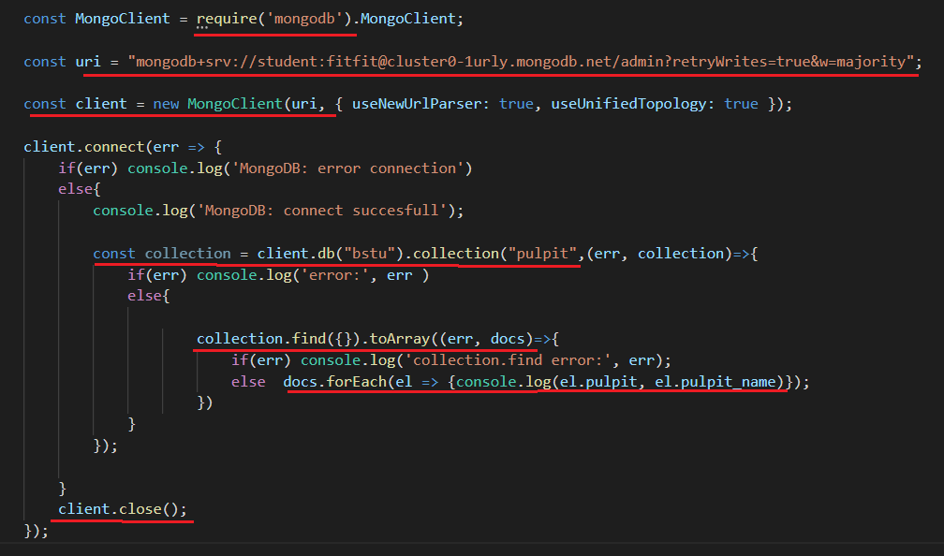


- MongoDB: client, connect, db, collection, find, insertOne, insertMany
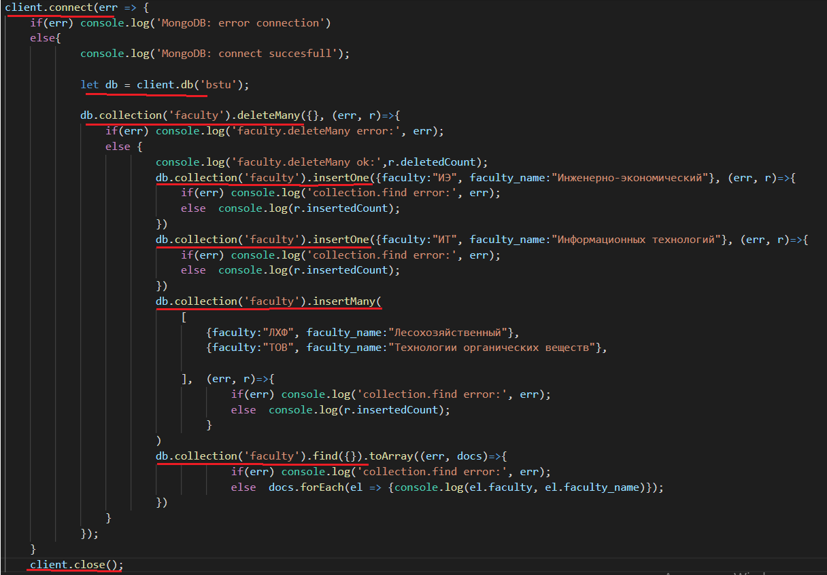

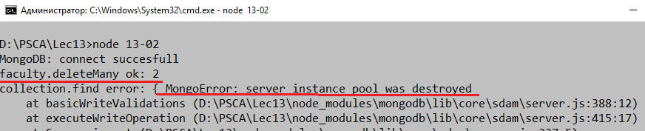

- MongoDB: продолжение
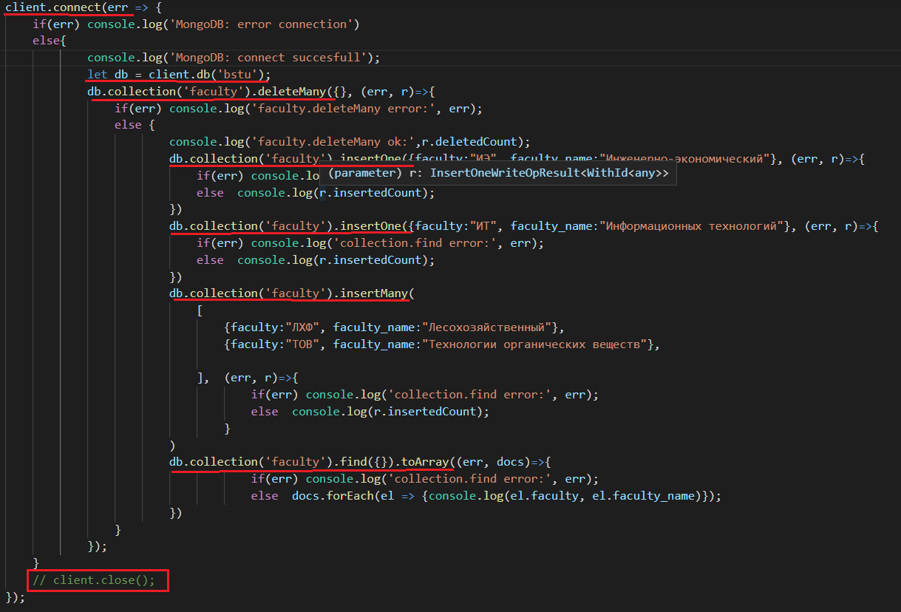
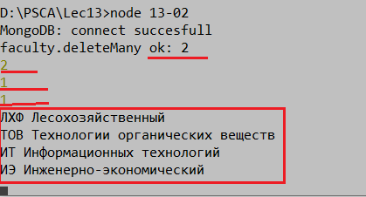

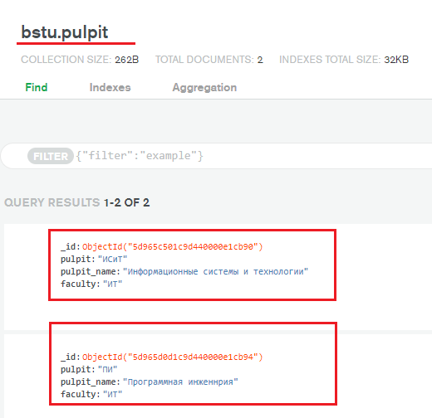

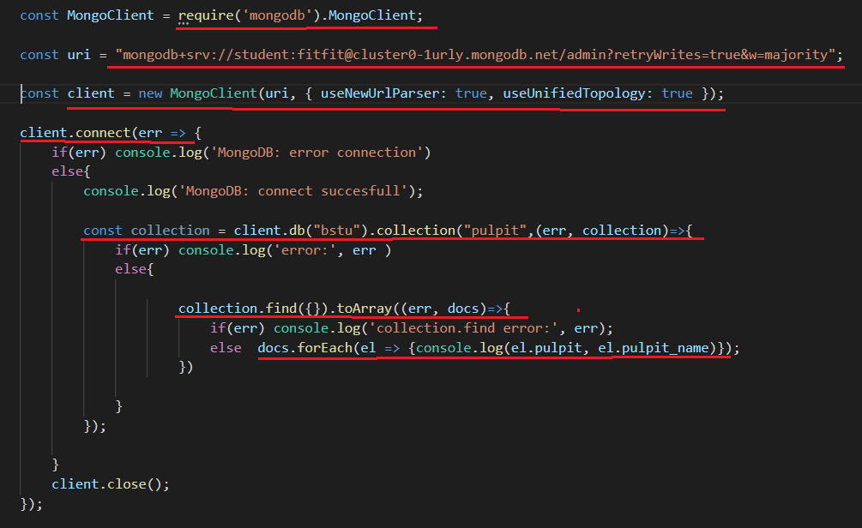

- MongoDB:продолжение
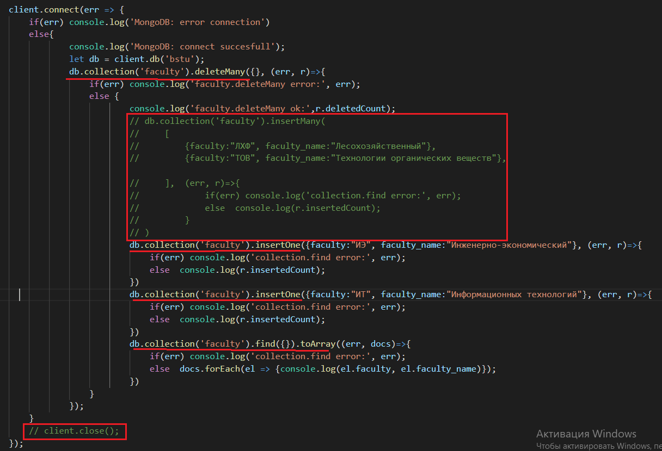
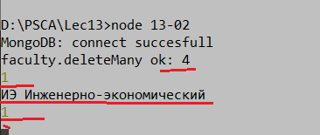

- MongoDB: client, connect, db, collection, find, update

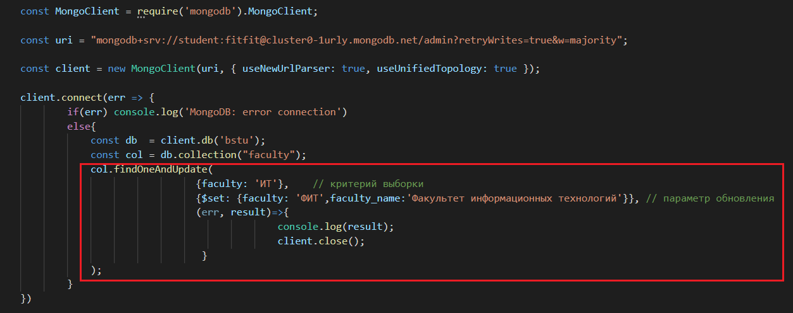

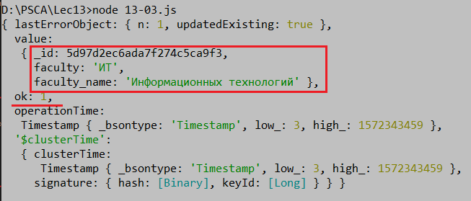

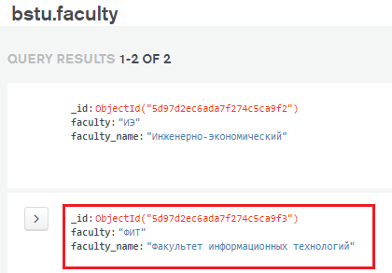
- MongoDB: client, connect, db, collection, find, update, returnOriginal=false
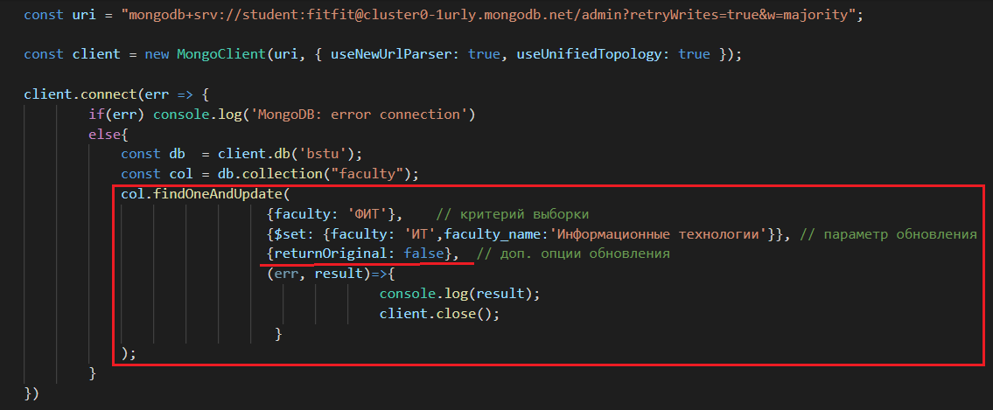

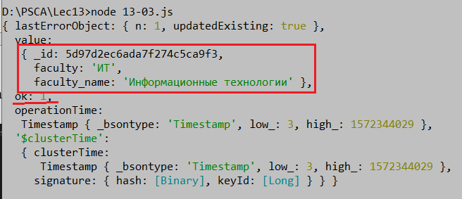

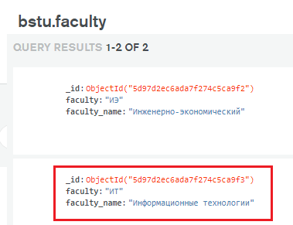

Mongoose
Odm object-document mapper

- MongoDB:
- MongoDB:
- MongoDB:
- MongoDB:

- MSSQL:

